Take more classes- pay less!  $10 less for 2nd and $20 less for 3rd class! (valid for 1 lesson a week in-studio classes only) – for different instrument and/or different students in the same family  Military Discount: $10 Off per month, can be applied only once per account | 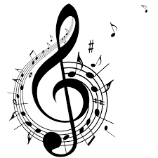 |  | 2 Payment options:  - Automatic Debit from your credit or credit card (taken out of your account on the 25th of every month for the following month)  - Check payments - set of checks: January-June due on Nov., 25;  July- December due on May, 25  You date every check for each month, for example: check for January-January, 1, for February-February, 1 and so on. Check gets deposited as the month comes, so you do not prepay. This is for mutual convenience only. If you stop lessons before your check set is over, we give you the checks back.  We have NO contract and NO Registration Fee
Monthly Fee for In-Studio classes, 1 lesson a week

Private one-on-one lessons for all instruments for children and adults |  | 30 min |  | $100 a month
 |  | 45 min |  | $150
 |  | 60 min |  | $200
Semi-private lessons  (2 students): guitar, violin, voice, flute, clarinet for children and adults |  | 30 min |  | $140
 |  | 45 min |  | $190
 |  | 60 min |  | $250
Monthly Fee for In-Studio classes, 2 lessons a week

Private one-on-one lessons for all instruments for children and adults |  | 30 min twice a week |  | $190 a month
Before you take any classes you can get a Try-Out for $10 (15 min) or $20 (30 min)
Instrument rentals: $1 a day
No refunds or credits
We offer: Piano, Voice, Guitar (+Banjo and Ukulele), Violin, Drums, Flute, Clarinet, Saxophone, Trumpet, Trombone, Harmonica lessons.
wocjax.com Facebook/WOCacademy (904) 477 1552

